Name: Aetesam Asfar Ullah Roll No: 02-134232-092
Title: The Power of Now
Subtitle: A Guide to Spiritual Enlightenment
Year: 1997
Place of Publication: Vancouver
Author: Eckhart Tolle
Genre: Self Help

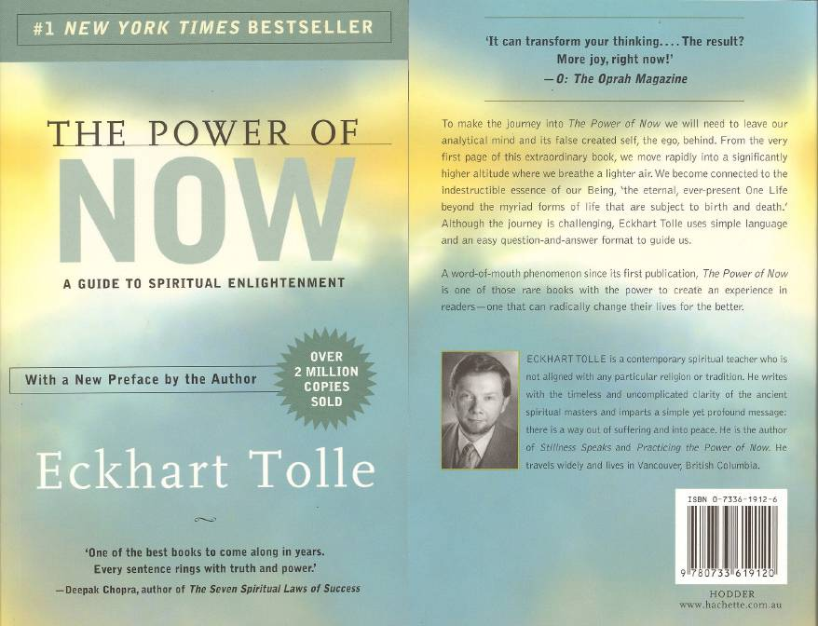

Author:
Eckhart Tolle, born in 1948 in Germany, is a spiritual teacher and author known for his teachings on mindfulness and living in the present moment. He struggled with depression and anxiety in his early life and experienced a profound spiritual awakening at age 29, which transformed his life. Tolle draws from various spiritual traditions without affiliating with any specific religion. He lives in Vancouver, Canada, and collaborates with figures like Oprah Winfrey. Tolle's notable books include Stillness Speaks, A New Earth, Guardians of Being, and Milton's Secret. The Power of Now emphasizes living in the present moment as a path to inner peace and enlightenment. The book is not specifically dedicated, and there is no widely noted foreword writer.
Why Eckhart wrote this book?
Eckhart Tolle's journey from profound anxiety and depression to inner peace and presence is truly inspirational. His transformative experience allowed him to tap into a deeper sense of being, free from the turmoil of his mind. The Power of Now is a testament to this awakening, guiding others towards a similar path of mindfulness and present-moment awareness.
People began asking him how they could experience this same peace, and his answer was simple: it is already within you, but the mind’s constant noise blocks it. This realization led him to write The Power of Now—a guide to help others quiet their minds, let go of suffering, and live fully in the present.

Main Theme
The Power of Now by Eckhart Tolle is a book about the importance of living in the present moment. The main idea is that real happiness and peace come from focusing on what is happening right now, instead of worrying about the past or future. Tolle explains that our minds are always full of thoughts and worries, which stop us from truly enjoying life.
He suggests that by practicing mindfulness and paying attention to the present, we can feel more at peace and understand ourselves better. The book gives simple exercises and tips to help readers calm their minds, watch their thoughts without getting lost in them, and let go of negative thinking.
Tolle also teaches that accepting the present moment as it is, without trying to fight it, can bring a deep sense of calm and happiness. By doing this, we can reduce stress and anxiety and live a more peaceful and meaningful life.

Summary of the Book:
Eckhart's first chapter explains that we are not our thoughts. He introduces the idea that identifying with the constant chatter in our minds creates unnecessary suffering and keeps us from fully experiencing the present moment.
In the second chapter, Tolle discusses how resisting the present and identifying with our thoughts leads to pain. He introduces "watcher" consciousness, a state where we observe our thoughts without attachment, allowing us to detach from pain.
The third chapter emphasizes the importance of being fully present. Tolle provides practical advice and exercises to help readers focus on the "now" and achieve a state of mindfulness.
In the fourth chapter, Tolle explores how the mind avoids the present through worry and regret. He explains that these strategies create stress and hinder us from living fully, encouraging readers to break free from these patterns.
The fifth chapter delves into the concept of "presence." Tolle describes how being fully aware and engaged in the present moment leads to deeper peace and fulfillment.
In the sixth chapter, Tolle introduces the practice of connecting with the "inner body." This involves becoming aware of the subtle energies within our bodies, which helps anchor us in the present moment and deepen our sense of inner peace.

Chapter seven explores ways to connect with a deeper dimension of consciousness, which Tolle calls the "Unmanifested." He discusses practices like stillness, silence, and surrender to help us access this deeper state of being.
The eighth chapter explains how living in the present moment can improve relationships. By being fully present and aware, we can relate to others more authentically and compassionately.
In the ninth chapter, Tolle discusses finding true peace by transcending the duality of happiness and unhappiness. He explains that accepting the present moment without judgment leads to a deeper sense of peace.
The final chapter discusses the concept of surrender. Tolle explains that surrendering to the present moment means accepting it fully and letting go of resistance. This acceptance leads to inner peace and harmony.
In conclusion, The Power of Now by Eckhart Tolle teaches the importance of living in the present moment to achieve true happiness, peace, and spiritual growth. Tolle emphasizes that much of our suffering comes from identifying with our thoughts and resisting the present moment. By practicing mindfulness and being fully present, we can transcend the ego, detach from pain, and experience a deeper sense of inner peace. The book provides practical advice and exercises to help readers quiet their minds, connect with their inner selves, and improve their relationships. Through acceptance and surrender to the present moment, we can live a more fulfilling and harmonious life.

Author's view of the book
Eckhart Tolle thinks The Power of Now helps people find peace. He wrote it to show how living in the present moment can make life happier. Tolle wants readers to use the book to feel less stressed and more joyful. He believes the teachings should be practiced and felt, not just understood with the mind. Simply put, Tolle sees the book as a tool to help people live better and happier lives.

Organizational Structure
When I first read The Power of Now, I appreciated its unique Q&A format, which felt like Tolle was directly answering my questions. The book's ten chapters guide readers from understanding how the mind creates suffering to realizing the power of living in the present.
Tolle's writing is simple yet insightful, using real-life examples and analogies. One memorable comparison is likening the mind to a relentless voice, which helped me become more aware of my thoughts and avoid overthinking. The book combines practical advice with spiritual wisdom, making it a thought-provoking and life-changing read for those seeking a deeper connection to the present moment.

Personal Opinion
For me, this book resonated deeply because I am a programmer who constantly overthinks every project. I tend to procrastinate, overanalyzing ideas instead of just coding. Reading The Power of Now made me realize how much I get stuck in my own thoughts without even noticing.
While I’m still in the process of changing, this book has helped me become more aware of when I’m lost in overthinking. I’m learning to focus more on the process of coding rather than stressing about the outcome. Some days are easier than others, but I’m starting to enjoy problem-solving without as much pressure.
I’ve never been a big reader, but I finished this book surprisingly fast. The Power of Now is definitely something I’ll come back to as I continue working on staying present.

Recommendation
I highly recommend The Power of Now to anyone on a spiritual journey, individuals struggling with anxiety or overthinking, and professionals like programmers who overthink their work. The book offers practical advice for living in the present moment, reducing stress, and improving well-being. The Q&A format directly addresses common concerns, making the book feel personal and practical. Personally, this book inspired me to adopt a more mindful and present approach to life, greatly enhancing my daily experiences. The Power of Now is a transformative read worth revisiting.

